**Memory Mapping**

Infineon Memtool is used for reading memory from the address location of the board.

**Step to memory map a new variable**

Step 1: Declare the variable in .h file or even in the .c file

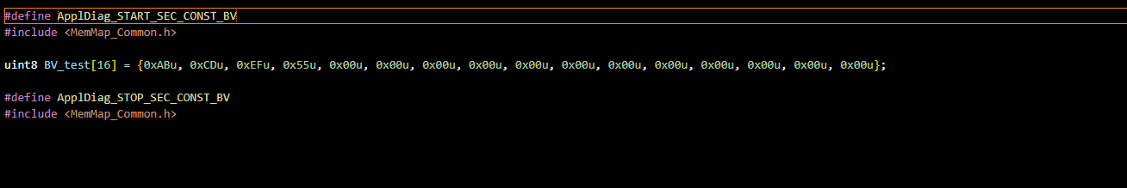

Here I am declaring it in appldiag.c, give the name of your choice for starting and stopping the memory section. Or else it is to be declared in .h file

Include the header file (MemMap_Common.h) where the memory sections ApplDiag_START and STOP is defined

Here since I am declaring it in .c file, I will be initializing the variable here itself.

Step 2: If Declared the variable in .h file, we need to initialize it in .c file in between the memory section definition

For e.g.:

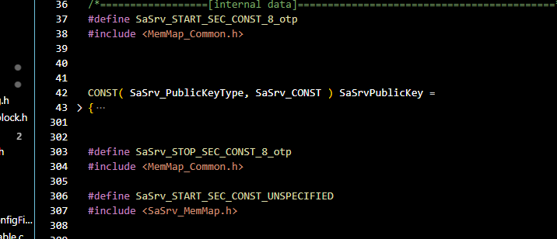

Step 3: In MemMap_Common.h

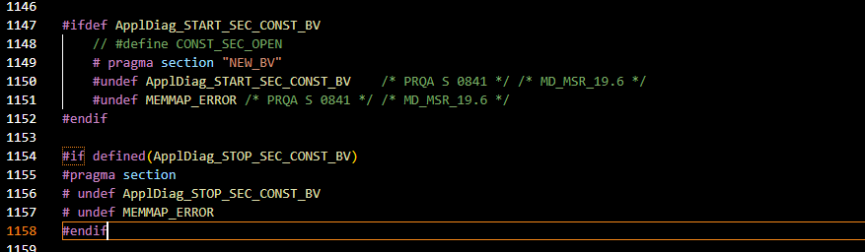

Here the Start and Stop sections are defined

The pragma section(give any name) is used to define the memory location where the variable need to be stored

Step 4: In **.ld file** and **linker script.h** (20 make -> Bin)

Add the new section and KEEP the pragma name defined in the memory section definition

Here NEW_BV is the pragma section name defined which I added in the linkerscript and .ld file.

In **.ld file**

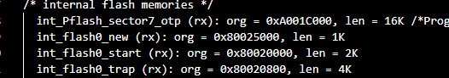

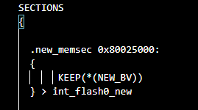

In **linker script.h**



